**EXPERIMENT 3-1**

**CENTRIPETAL FORCE**

To keep an object in circular motion a force called centripetal force is needed. The force pulls the object toward the center of the circle. It does not change the object’s speed, only its direction, as it moves in the circle. Since the direction changes, the object is accelerating. The accelerating called centripetal acceleration is toward the center of the circle and is given as

a = v2 / r where:

**a**- *acceleration*

**v**- *constant* *speed*

**r**- *radius* *of* *the* *circular* *path*

Newton’s law of acceleration, when applied to centripetal force is as written as follows:

F = ma

F= mv2 / r

**Objective**

To determine the centripetal force acting on a rotating object

**Materials**

pen case stopwatch

fishline cork

paper clip set of masses

platform balance

**Procedure**

1. Measure the mass of the cork. Hang a 50 g mass on one end of the fishline (*this serves as the theoretical value for the centripetal force*). Insert the other end into the pen case. The cork must be tied to this end. Support the mass with one hand and hold the pen case in the other.
2. Fasten a paper clip just below the bottom of the pen case. Whirl the cork by revolving the pen case. Slowly release the 50 g mass and adjust the speed of revolution so that the paper clip stays in place.
3. When the motion is under control so that the mass is stationary, measure the time required for 25 revolutions and calculate the time of a single revolution.
4. Next, grasp the string at the bottom of the pen case to mark the position of the string while the cork is moving. With the string in this position, measure the radius **r.**
5. For the same mass change the radius of the rotation first to the smaller value and then to a larger value. Observe the corresponding change to maintain the mass at the stationary position.

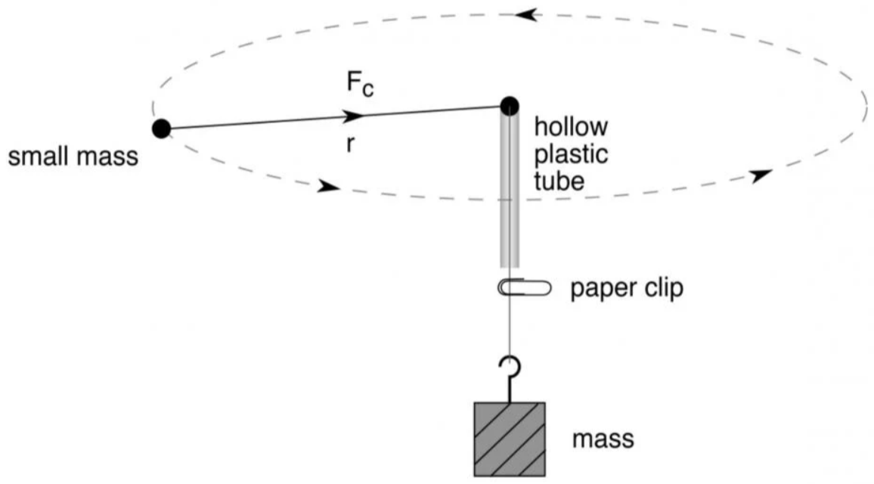

**cork**

**Data and Answer Sheet**

1. Data and Results

|  |  |  |  |  |  |  |
| --- | --- | --- | --- | --- | --- | --- |
| **Trial** | **m**  **kg** | **r**  **m** | **Period**  **s** | **v**  **m/s** | **v2**  **m/s** | **F**  **N** |
| 1 |  |  |  |  |  |  |
| 2 |  |  |  |  |  |  |
| 3 |  |  |  |  |  |  |

where: **N** – *no*. *of* *revolution*

**V = 2πrN** **t** – *total* *time*

**t** **r** – *radius* π = 3.1416

**V** – *speed*

Average centripetal force (experimental value) - _______________

Centripetal force theoretical value (mass x gravity) - _______________

Percent difference (% diff) between the experimental (*F*exp) and theoretical (*F*) centripetal force:



*Note:* In general, a percent difference of less than 5% indicates a good agreement (accepted value) between the experimental and theoretical results; between 5% and 10% is considered a fair agreement; larger than 10% indicates a bad agreement.

If your percent difference is greater than 10%, what maybe the reason(s) for the disagreement between the theoretical and experimental results?

____________________________________________________________________________________________________________________________________________________________

**Conclusion**

_________________________________________________________________________________________________________________________________________________________________________________________________________________________________________________________________________________________________________________________________________________________________________________________________________________________________________

**Questions and Problems: Centripetal Force**

1. Explain the difference between centripetal force and centrifugal force.

__________________________________________________________________________________________________________________________________________________________________________________________________________________________________________

1. Describe the motion of the cork if the string is cut. How is the concept of tangential velocity related to this?

__________________________________________________________________________________________________________________________________________________________________________________________________________________________________________

1. What physics principle explains the removal of water from the clothes in a spin dryer? Explain.

__________________________________________________________________________________________________________________________________________________________________________________________________________________________________________

1. Change the following into other angular measures:
   1. 3/4 𝛑 ________ ________
   2. 750° ________ ________
   3. 100 rev / min ________ ________
2. An airplane makes a loop of radius 500 m. The central acceleration of the airplane is 35 m/s2. Calculate the angular velocity.
3. Calculate the centripetal force acting on a 1100 kg car that travels around a highway curve of a radius 145 m at 25 m/s2
4. What mass could be lifted by the centripetal force of an object having a mass of 98 g if it were revolving in a horizontal circle 22 cm in diameter and 200 rev/min?
5. A heart patient, walking on a circular track, completed 5 laps around the track in a total time of 5.3 mins. Determine the angular velocity of the patient.
6. If the patient in the previous problem is walking on a track 5.0 m radius, determine the linear velocity of the patient.